TRACEY LARCOMBE
Contact: +44 7590430301
tracey.larcombe@gmail.com

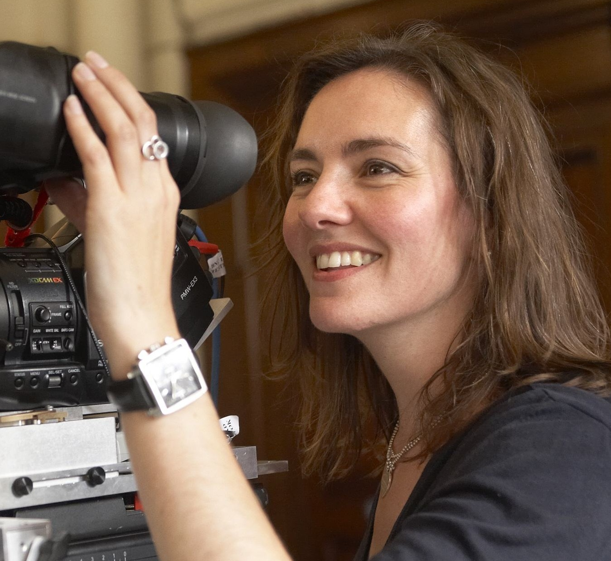
Profile

Director and writer Tracey Larcombe is a TV Drama, short film, series and documentary maker who comes from a strong background in programme production for SKY & the BBC.

With a track record for directing intelligent, eye-catching projects in a variety of genres, Tracey is a natural storyteller who enjoys communicating with an audience in an engaging, entertaining & cinematic way. Tracey regularly directs TV drama series including ‘Casualty’ for BBC1 and ‘Hollyoaks’ for Lime Pictures/Channel 4, she has also directed over 30 episodes of BBC series ‘Doctors’.

She is currently attached to direct one of her own projects ‘Season To Taste’, based on Natalie Young’s best selling book ‘Season to Taste – Or How to Eat Your Husband’, which is in development with Mainstreet Pictures.

Tracey has a number of other writing & directing projects in development with David Baddiel, including, feature screenplay ‘Mother in the Cupboard’ co-written with David, as well as developing a low budget feature/TV series adaptation of his best selling novel ‘Time for Bed’.

Her short film, ‘Being Lionel’ starring Lionel Blair, received excellent reviews within the industry, and was selected for the IFS Festival in LA and for a ‘Women in Film & Television’ special screening event in September 2014.

Completed Directing Work
- ‘Hollyoaks’ – 5 episode block as part of ‘6 weeks of Summer’ season – TX August 2017
- ‘Casualty’ – ‘When the Whistle Blows’ – BBC, TX April 2017, producer Erika Hossington
- ‘Casualty’ - ‘Shock to the System’ - BBC, TX October 2016, producer Gail Evans
- ‘Doctors’ – 33 episodes 2014 - 2016, various producers
- ‘Being Lionel’ - Wrote, produced and directed a short film starring Lionel Blair (2013)
- ‘Capturing the Gains’ – short film series - Produced, wrote and directed 4 short films for charity highlighting the social and environmental issues facing workers in various industries in China and Africa, narrated by Bernard Hill. (2012)
- 'StreetDance - The Moves' (Vertigo Films) shot in 3D, the dance DVD spin off featuring the cast from the hit movie 'StreetDance 3D'. (2011)
- ‘FC Dave’ - Mockumentary series for UKTV/Dave starring David Baddiel. (2010)
- 'In Spite of All the Danger' (E4) Wrote, produced and co-directed hour long documentary commissioned by E4 on artist & director Sam Taylor-Johnson's work and first feature film, 'Nowhere Boy' (2010) Pick of the day for Radio Times

Praise for 'Being Lionel'

‘I enjoyed it very much. Funny, human, clever, gentle and slightly dark! What an achievement’ - Chris Ecclestone - Actor

‘Fantastic work! Polished, and very smart writing’. Gareth Edwards – Director (Monsters, Godzilla, Star Wars – Rogue One)

‘Being Lionel was really good. It's poignant, funny and doesn't hang about - feels like a proper short. And it was definitely right to go out on Lionel's feet!’
David Baddiel - Comedian and writer

‘Really good - enjoyed it a lot - and I don't generally like short films. Tap dancing end shot - perfect!’ Nick Love - Director

‘It is a sweet tale and I love the script. Please, please let me shoot your next one.’
Seamus McGarvey – Cinematographer (Atonement, Avengers Assemble, The Hours, We Need to Talk about Kevin, Godzilla, Nocturnal Animals)

Current Projects in development:
- 'Mother in the Cupboard' – feature screenplay which she is writing & developing with David Baddiel, produced by Kevin Loader (creator/co-writer/co-director)
- 'Back in the game' – TV sit-com in development (writer/director)
- 'Time for Bed’ – Feature/TV series - comedy drama she is adapting from David Baddiel’s book of the same name (co-writer/director)
- ‘Season to Taste’ – TV Series dark comedy she is developing with writer Rachel Paterson from Natalie Young’s best selling novel, ‘Season to Taste – Or how to eat your Husband’ (director)
- ‘The Fishing Times’ – feature film/TV series at synopsis stage, with Bernard Hill attached. (Writer/director)

Agent Details
Alex Rusher – Independent Talent
alexrusher@independenttalent.com
T: 020 7636 6565

Website
http://www.eggcreativeproductions.com/work.html

